Adopt a Road
Bradford Conservation Commission
2026 Report
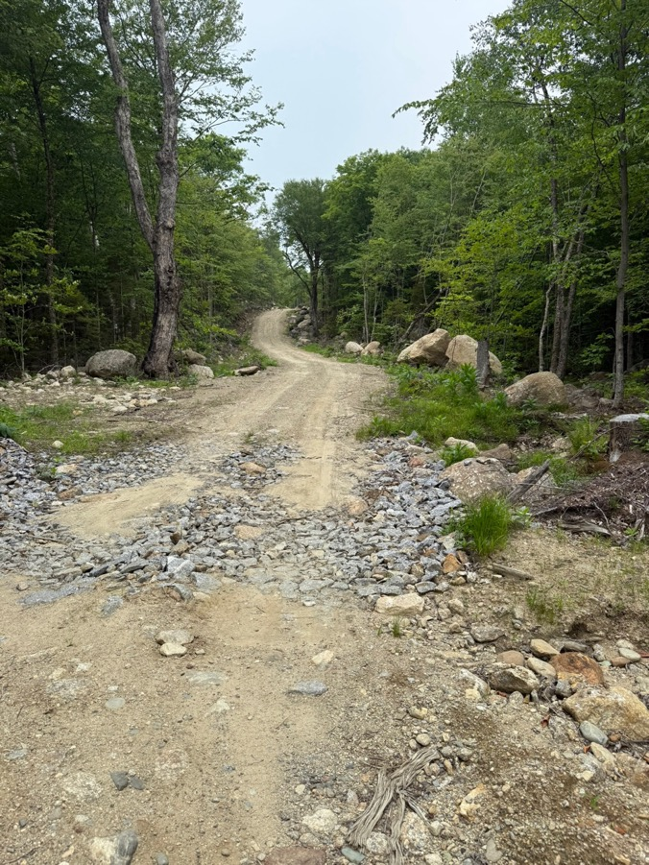
Old Mountain Road 2026
Introduction
This report is the product of Bradford citizens’ efforts to monitor the condition and usage of our Class VI roads. These roads provide access to residences and back lands and are often incorporated into trails for non-motorized recreational activity. In addition, they serve as access lanes for emergency fire and rescue services. The surveillance and report are a function of the Bradford Conservation Commission to prevent further degradation of these valuable resources.
2026 Update
This is an updated version of the monitoring reports from 2018 to present. Some of the previous documentation has been retained if there is an absence of substantial change as reflected in more recent observations. Extreme rain events associated with climate change may occur more frequently in future years. Given these conditions and the lack of maintenance, it would be reasonable to expect an acceleration in the deterioration of Class VI roads. This would be of particular concern for sections that have steep gradients, are poorly drained and sandy. In addition, under these conditions the impact of truck, dirt bike, and ATV traffic on erosion may be accentuated. Deterioration of the roads will further limit fire and rescue access.
Notable updates for 2026:
- Continued erosion observed on many roads. Particularly vulnerable are Carter Hill, Day Pond, Dunfield, and Deer Valley Roads.
- Fire Dept. and BCC representative traveled Rowe Mtn and Day Pond Roads in Fall 2025 to assess obstructions to fire/rescue access.
- Sections of Old Mountain Road have been upgraded with rock/gravel since the 2025 report.
- Significant rehabilitation of Rowe Mtn. Road with rock/gravel planned by Sunapee Snowmobile Club for Fall 2026.
- Driveway permit and upgrading initial section of Blaisdell Hill Road has been authorized by the Select Board.
- All Roads:
  - Dates on Mud Season Road Closure signs continue to fade. The Highway Dept. authorized road monitors to refresh the dates on these signs which is currently in progress. In addition, monitors have recently been authorized to provide minor repair to signs damaged by weather or traffic. The Road Agent will be alerted if more significant repairs are needed.
  - Beginning and end points for some roads (ex., Blaisdell Hill Road, Bible Hill Road, etc.) still need to be verified. This is highlighted given recent discussion regarding building on Class VI roads.

Class VI Road Condition Definitions
Road conditions may be classified by the volunteer road monitor based upon the following guidelines. The guidelines were developed to present realistic expectations for these gravel roads which are not maintained by the Town of Bradford. As these roads are easily damaged by motorized travel during wet conditions, such travel is not recommended.

Excellent Generally suitable for licensed vehicles and non-motorized travel.

Good Suitable for licensed vehicles and non-motorized travel, but not excellent. May have isolated rocks and mud.

Fair More frequent and significant road hazards may be encountered. Appropriate only for non-motorized travel and licensed 4-wheel drive vehicles with high ground clearance.
Poor Substantial and frequent mud and rock obstacles are present. Suitable
only for non-motorized travel and specialized, licensed 4-wheel drive vehicles.

The Bradford Conservation Commission assumes no responsibility for the accuracy of these observations noting that a comprehensive professional assessment has not been done and road conditions change. Travelers must use their own discretion in traveling these roads and travel at their own risk.
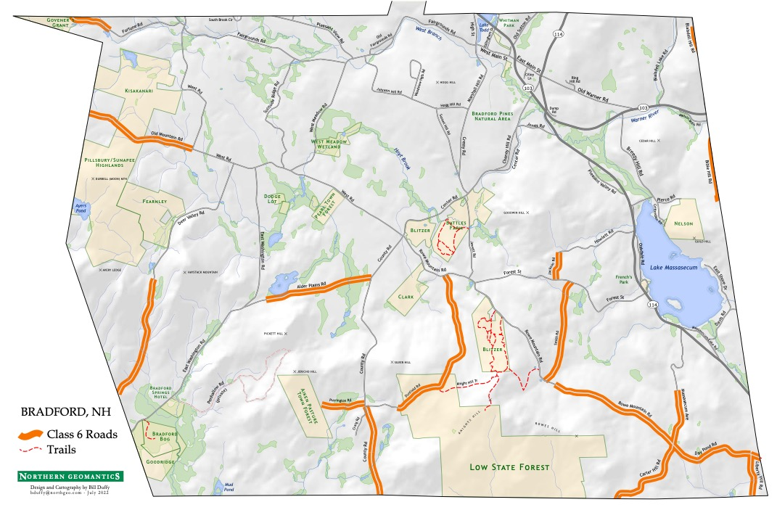
Bradford Class VI Roads

Table of Contents
Alder Plains Road 5
Bible Hill Road 8
Blaisdell Hill Road 10
Carter Hill Road 13
County Road 17
Day Pond Road 18
Deer Valley Road 21
Dunfield Road 23
Fortune Road 26
Jackson Road 27
Liberty Hill Road 28
Massasecum Ave 32
Old Mountain Road 34
Purrington Road 37
Rowe Mountain Road 39
Smith Road 41

Alder Plains Road

Monitor(s): George Beaton and Meg Fearnley

Date of Most Recent Monitoring: June 2026
Alder Plains Road runs between County Road and East Washington Road for a total of approximately 1.25 miles. Beginning at the junction with East Washington Road, it is about 0.2 miles to the start of the Class VI section signified by a “Not Maintained” sign. 2025 update: Road is rutted up just past the cluttered junk and vehicles but only as far as the culvert at the top of the hill which probably deterred further travel.
Miles Conditions
0.25 Up until this point, road is in GOOD condition with placement of crushed rock. A small building is encountered on the left side of the road which appeared to be occupied in the past. Numerous junk piles and cars/trucks along-side of the road.
0.75 Road surface is FAIR to GOOD, reasonably flat, but with significant mud puddles. One culvert juts up from the road surface.
1.0 Road continues to be in FAIR to GOOD condition but ends in water at approximately 1 mile (see pic)
Reversing course and starting at County Road, the following observations were made.
0.1 miles Road is reasonably flat and in FAIR to GOOD condition with mud puddles. Road ends in water as was the case from the entrance via East Washington Road.
Erosion: Modest amount of erosion as the road surface and surrounding land are relatively flat. However, there are numerous mud puddles. No significant changes to the road condition from 2022.
Obstructions: No problem for emergency access except for the permanent flooded section of the road close to County Rd.
Trash/Dumping: A burned vehicle beside the road on the left across from the Road Not Maintained sign and a large pile of debris beside the abandoned vehicles at the wetland have been removed.
Recreational Vehicle Trail Signage: None other than that the road is posted for closure on both ends for mud season. In addition, there were some new realtor signs in the field just before the water crossing.

Motorized/Non-motorized Activities: All looked consistent with last year’s monitoring.

Monitor Actions: The dates were refreshed at each end of the road on the orange signs.
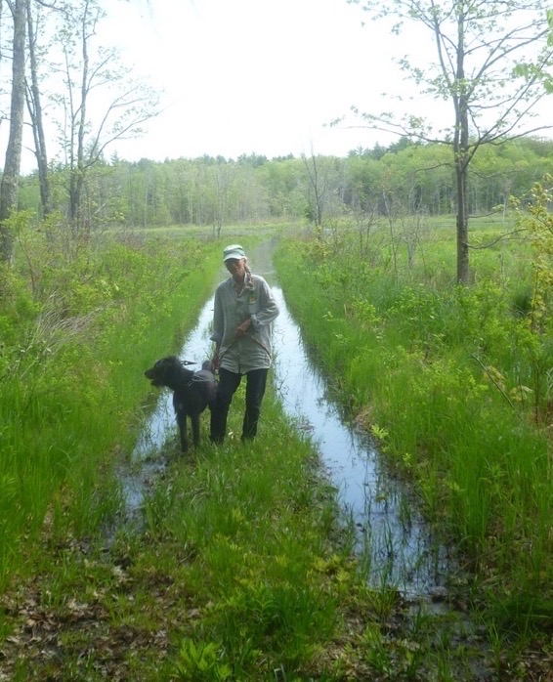
Submerged Section of Alder Plains Road 2022
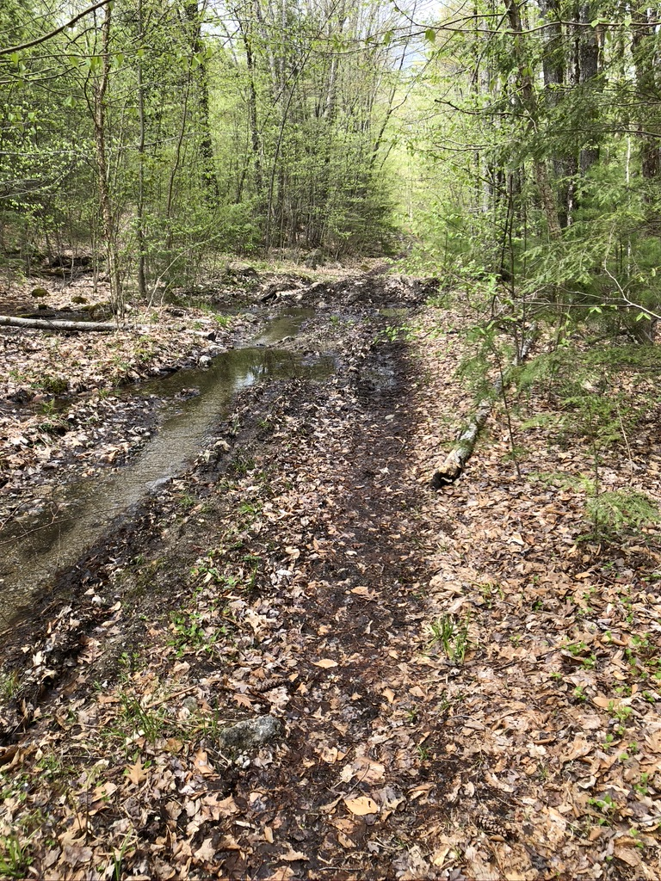
Spring 2020

Bible Hill Road

Monitor(s): Tom Dunne and Doug Southard

Date of Most Recent Monitoring: July 2022 {Not monitored in 2023-2026 due to brief road length ending in woods.}

Bible Hill Road starts in Warner at Melvin Mills, but cuts over to the town line in about .15 miles. From there it follows the town line at least till the former Pierce Road, with everything on the west in Bradford, and everything on the east in Warner. About half of the length is maintained by Warner under agreement with Bradford, but the other half is Class VI, maintained by the Tom Dunne.
Starting at the beginning of the Class VI road, the following landmarks were noted.

Mile
- Road maintained by Tom Dunne and is in EXCELLENT condition for a Class VI road.
0.3 Road downgrades to GOOD condition just after Dunne’s home.
0.35 Road converts to totally unmaintained and is in FAIR condition.
0.45 Warner/Bradford town line (approximately 800 ft from beginning of unmaintained section of the road).
0.49 Apparent end of Class VI roadway (approximately 200 feet from town line).

Erosion: Mud/pot holes with some large rocks noted in the unmaintained section.

Obstructions: No

Trash/Dumping: No

Recreational Vehicle Trail Signage: No
Mud Season sign present at beginning of unmaintained road section, however, no season dates are noted.

Motorized/Non-motorized Activities: Some motorized tracks noted in the mud.

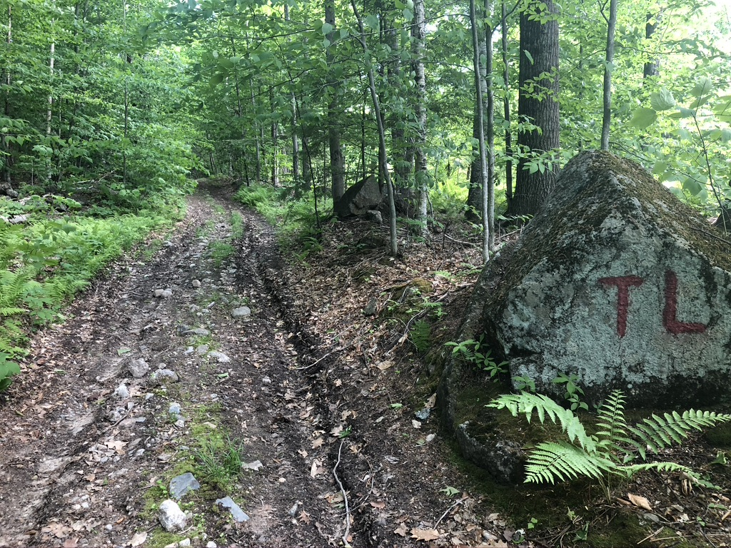
Spring 2020

Blaisdell Hill Road
Monitors: Patty Furness and Scott MacLean

Date of Most Recent Monitoring: May 2026

Description: The Class VI portion of Blaisdell Hill Road appears to begin soon after the Conforti-Adams residence, where a Town of Bradford Mud Season Notification sign is erected. The road follows the Bradford/Warner town line for approximately 0.2 miles and is in FAIR condition. The length of this Class VI portion of Blaisdell Hill Road is approximate, as there is no indication of where the Bradford/Warner town line crosses it.

Erosion: The road has significant rutting in the first 0.1 miles, due to vehicular travel in the past, and now exacerbated by erosion from rain events. Large rocks are exposed in the road in several areas. The road grade lessens and continues to the approximate town line.

Obstructions: None. Road remains passable for Fire/EMS vehicles.

Trash/Dumping: None

Recreational Vehicle Trail Signage: None

Motorized/Non-motorized Activities: Recent activity evidenced by clear tire tracks.
Monitor Actions: Dates on Mud Closure Signs refreshed.
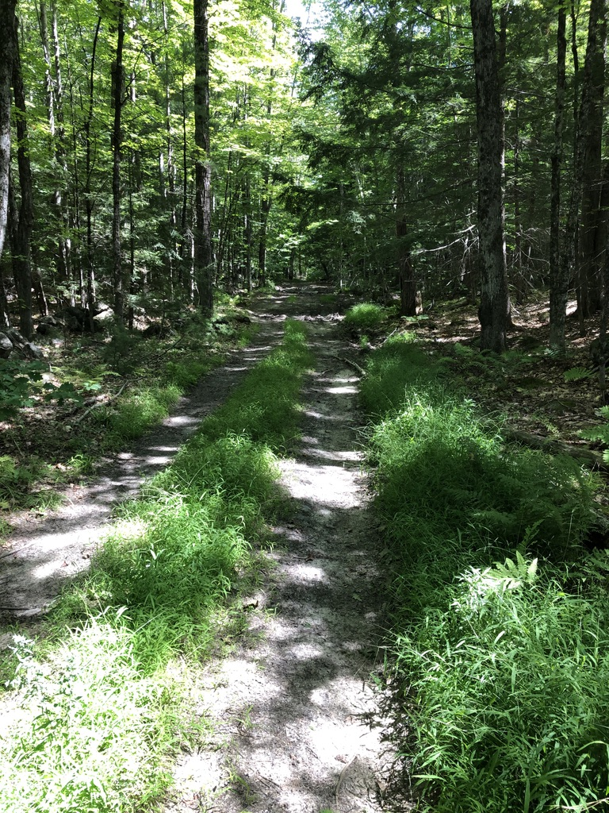
Spring 2022
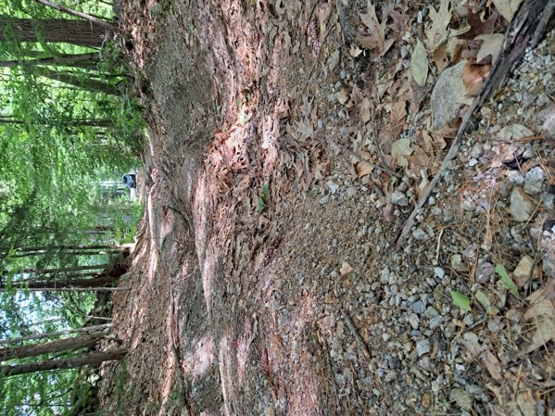

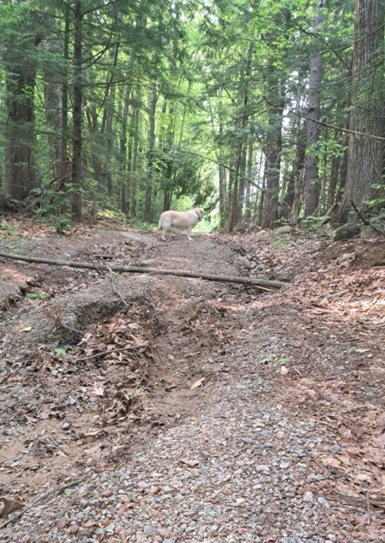
Blaisdell Hill Road 2025

Carter Hill Road

Monitor(s): Barb and Doug Southard

Date of Most Recent Monitoring: July 2026
Mileage: Starting at the junction with Rowe Mountain, Massasecum, and Day Pond Roads.
0.0 - 0.17 miles: Road climbs steeply uphill immediately from Day Pond/Massasecum Ave./Rowe Mt. Rd. junction. Road condition is FAIR to POOR, mostly exposed rock with some sandy areas.
0.17 - 0.25 miles: Road condition POOR, washout heavier, steep grade continues.
0.25 - 0.37 miles: Road flatter, condition improves to GOOD.
0.37 - 0.5 miles: Grade becomes steeper, road condition remains GOOD. Clearing on left side of road.
0.5 - 0.55 miles: Grade flat, road condition GOOD.
0.55 - 0.6 miles: Large, moderately deep mud wallow about 30' x 50' in diameter.
*.57 miles: Bypass trail cut into forest.
*.64 miles: Bypass exit.
0.6 - 0.75 miles: Road climbs steeply, extremely eroded, no soil present, small stream running down. Road condition extremely POOR.
*.74 miles: Large, horizontal tree root spans the entire road. About one and a half feet in height.
0.75 - 0.85: Condition improves, grade lessens, still climbing. Condition is FAIR.
0.85 - 1.0 mile: Road climbs steeper again, condition FAIR to top of hill and town line.
Erosion: Significant erosion from beginning to Hillsborough town line. Some sections essentially impassable except by articulated suspension. Some small bypasses have been cut into the adjacent woods to circumvent the worst sections. Overall, relatively unchanged since 2022.
Obstructions: One low lying area has roughly 6 inches to a foot of muddy water, perhaps 50ft by 30ft (see picture). Mud hole hasn't seemed to increase in size, but another bypass has been cut through the low-lying forest to allow ATVs to pass. The cut section is too small for Jeeps. *FIRST RESPONDERS: the mud wallow (.5 miles), the large tree root (.74 miles) and the impassable section (.57-.64 miles) immediately following the mud wallow would most likely prevent anything but a very large vehicle with very large tires from getting through.
Trash/Dumping: Some trash and an abandoned car.
Recreational Vehicle Trail Signage: Road posted closed for mud season at the junction of Day Pond/Massasecum/Rowe Mt Rds., but not at the Hillsborough town line at the top of the hill. Two ATVs seen from Carter Hill Road driving down Day Pond Road to Rowe Mountain Road in 2026.
Motorized/Non-motorized Activities: Significant tire tracks, including ATV and 4x4 truck/jeep. Abandoned vehicle noted at top of hill.

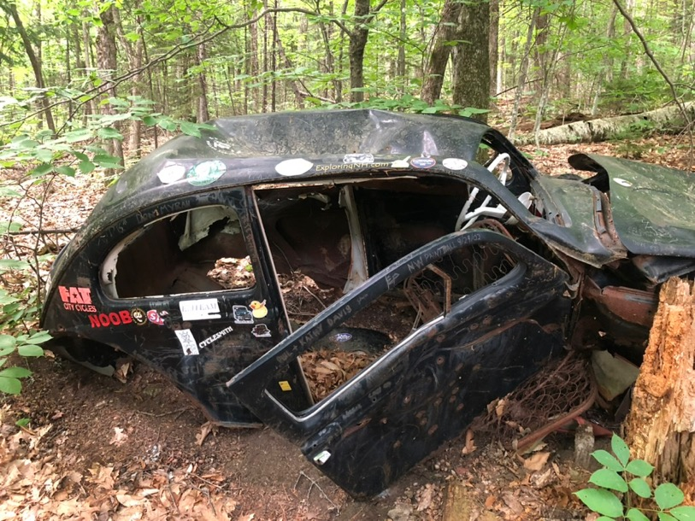
Abandoned Car on Carter Hill Road 2024
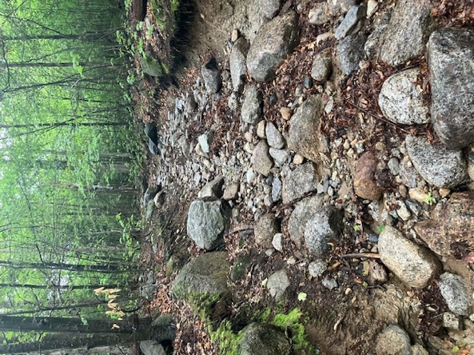
Carter Hill Road Rocky Section 2025

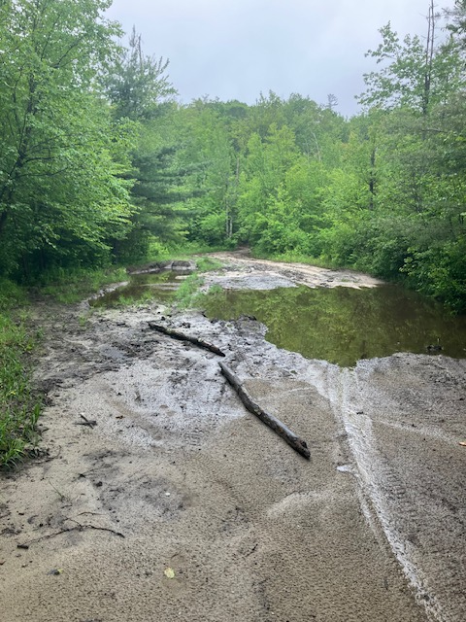
Carter Hill Road Mud Hole Tracks 2025
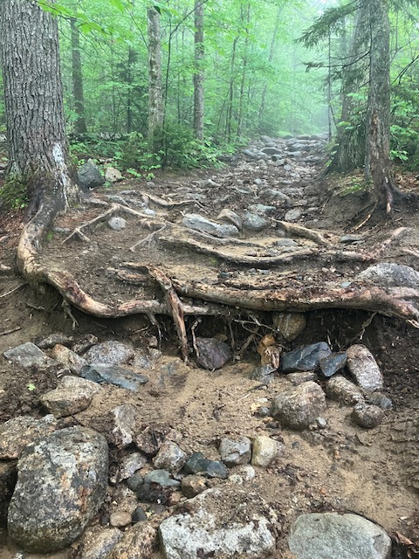
Carter Hill Road Obstruction 2025

County Road

Monitor(s): Bob Blank

Date of Most Recent Monitoring: May 2026

Mileage: Measured from end of town maintenance headed south toward Hillsboro.
0.37 Road maintained by local residents and is in EXCELLENT shape for a Class VI road, although somewhat of a single lane due to wetlands on both sides.

0.42 Short distal portion of road to the Bradford/Henniker town line is still GOOD having been upgraded by the state for their logging further down into Hillsboro several years ago.
Erosion: The County Rd. end is still in good shape, winter/spring was a bit tough on the privately maintained section although I think it’s been repaired. The short stretch after that to the town line is in better shape than last year. All in all in good shape.
Obstructions: No
Trash/Dumping: No
Recreational Vehicle Trail Signage: The road is posted for mud season closure at the end of the privately maintained section of the Class VI Road.
Motorized/Non-motorized Activities: Yes, multiple residences are located on this road.
Monitor Actions: None at this time.
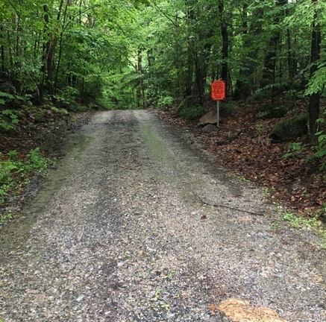
County Road 2021

Day Pond Road

Monitor(s): Doug and Barb Southard

Date of Most Recent Monitoring: July 2026
Starting at 4-way junction with Rowe Mountain Road, Carter Hill Road, and Massasecum Road.

Miles
- Road generally in FAIR to POOR condition with some large rocks (8-12 inches) over the first .25 miles.
0.37 Appears to be old OHRV damage near a water crossing on left (North side). Road varies from FAIR to GOOD.

0.7 Culvert washout first noted 2025. Updated pic from 2026 finds some improvement. (see pics)
0.96 Road enters 4-way junction with Liberty Hill Road and a private road before continuing on to Rt. 114. The last .25 miles varies from FAIR to GOOD due to crushed rock placed during logging operations. Some deterioration of these upgrades was noted in July 2026.
Erosion: Section closest to Rowe Mountain Road has significant erosion and rocks. Crushed rock placed on Liberty Hill end makes road a bit more stable, though erosion continues. Evidence of previous off-road ATV “mudding” on North side of road appears to be returning to more natural condition. Significant erosion noted to culvert at 0.7 mile mark.

Obstructions: Nothing significant other than the large rocks in first .25 miles.
Trash/Dumping: No significant dumping noted.
Recreational Vehicle Trail Signage: Mud Season closure sign present at Southeast end of the road. Closure dates very faded. Refreshed during 2025 monitoring. Needs current attention.
Motorized/Non-motorized Activities: Old off-road embankment damage as noted above. No current activity directly observed.

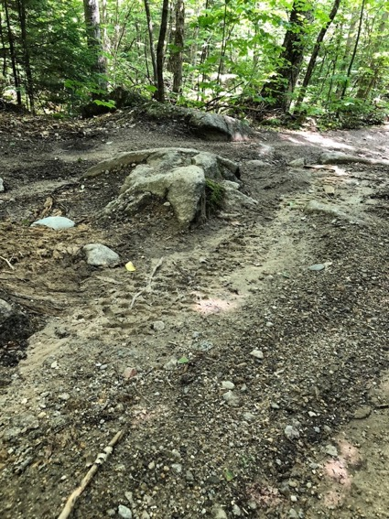
Day Pond Road: 2018 & 2026
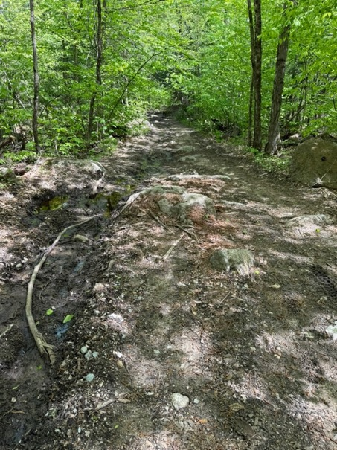
Day Pond Road: 2018 & 2026

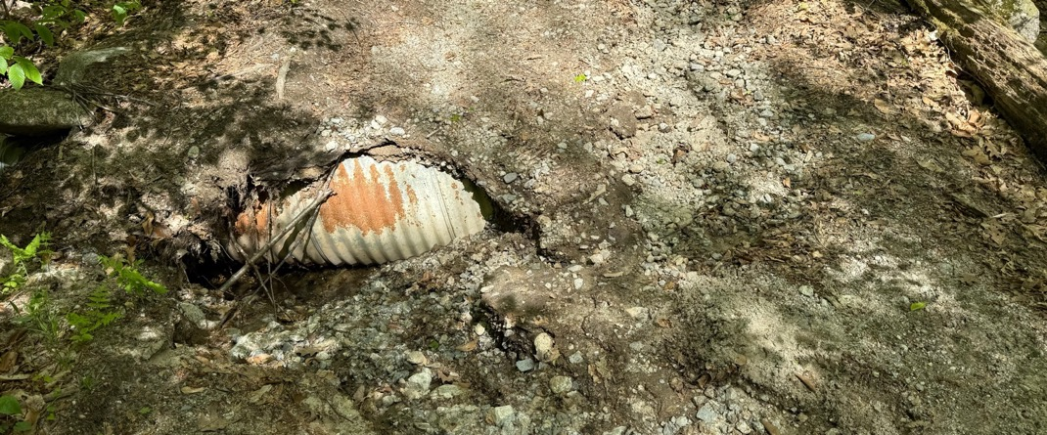
Newly eroded culvert 2025
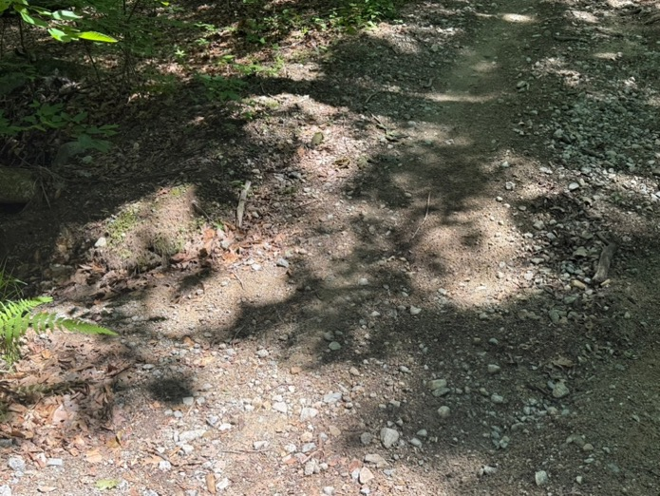
Culvert Improvement Noted 2026

Deer Valley Road
Monitor(s): Meg Fearnley and George Beaton

Date of Most Recent Monitoring: May 2026

Erosion: Erosion has worsened in two long sections of the road where the stream bed is the road. A noticeable degradation from last year. Road mostly FAIR with two very POOR sections.
Obstructions: Gate at Bradford end closed but not locked. None, mostly passable with a 4X4 truck except for one spot with an unavoidable jutting rock outcrop close to the Bradford end.
Trash/Dumping: None
Recreational Vehicle Trail Signage: Road closure signs for mud season are present on both ends of the road and the dates were refreshed.
Motorized/Non-motorized Activities: Evidence of recent trail bikes and ATVs.

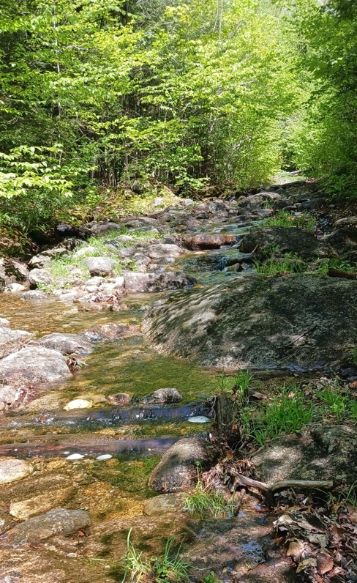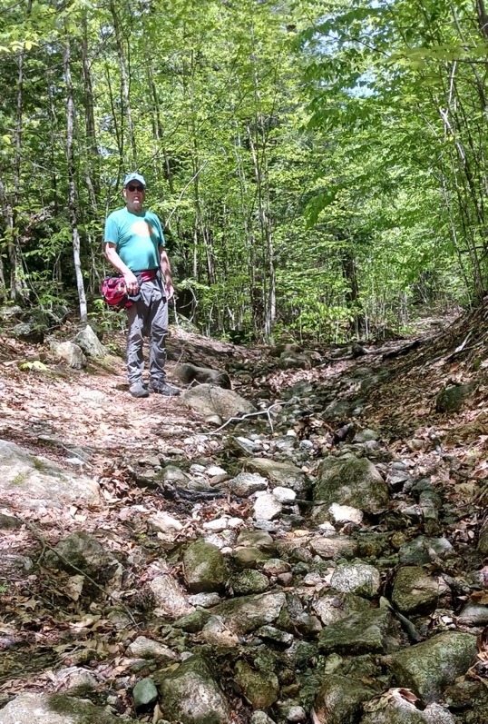
Deer Valley Road 2025

Dunfield Road
Monitor(s): Nathanial Bruss
Date of Most Recent Monitoring: June 2026

Mileage: Beginning at the old school house site on West Dunfield Road, the Class VI section is about 1.92 miles long.
0.00 Initial section is FAIR with some erosion. There is one damaged water bar after the road turns away from the state log landing and parking area. Then the road conditions deteriorate significantly to POOR after the Harriman cellar hole around .25 until just after the view clearing to the southeast. There are no fewer than 6 damaged/nonfunctional water bars with only 1 or two functioning water bars. This section of road is a steady fairly steep grade and very rocky and eroded with water running down the road in places.
0.53 Road condition moves from POOR to GOOD
0.6 Top of hill; Howlett cellar holes.
0.89 Road starts heading downhill; condition moves back to FAIR due to erosion.
0.93 Road condition deteriorates to POOR with extensive washouts and large rocks.
1.32 Unmaintained section ends. Remaining 0.6 miles of roadway to junction with Rowe Mountain Road is
in EXCELLENT condition as it is privately maintained as a driveway.
Erosion: Erosion has increased on the “west” end of the road.
Obstructions: Extensive and significant erosion on the Eastern section makes the road essentially unpassable.

Trash/Dumping: No
Recreational Vehicle Trail Signage: Both ends of the road have the closed for mud season signs.
Motorized/Non-motorized Activities: Small amount of Jeep traffic is evident by tire tracks and rocks spun out of water bars.

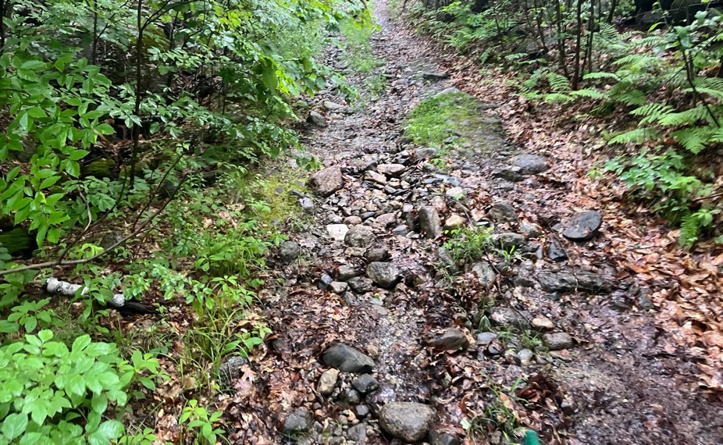
Dunfield Road 2026
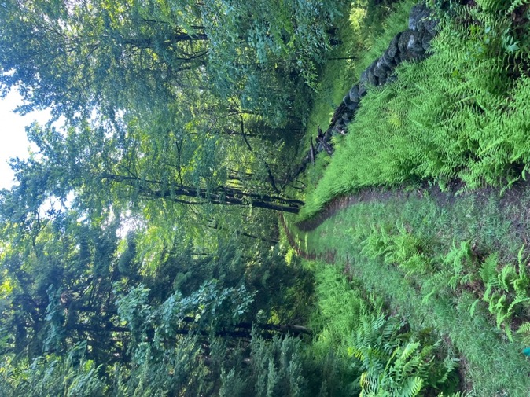
Dunfield Road 2026

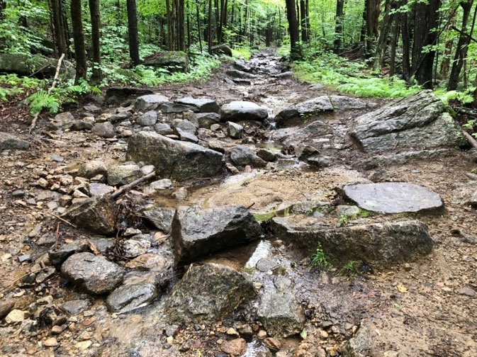
Dunfield Road Washed Out Section 2018

Fortune Road

Monitors: Patty Furness and Scott MacLean

Date of most recent monitoring: May 2026

Narrative: The Class VI portion of Fortune Road (past the McDonald residence) is maintained in EXCELLENT condition by routine grading and addition of hard pack as needed by John McDonald. It is used year-round by Joy Nowell to reach her home in Newbury, located just over the Bradford town line. The length of this section is approximately 0.5 miles

Erosion: None

Obstructions: None

Trash/Dumping: None

Recreational Vehicle Trail Signage: None

Motorized/Non-motorized Activity: Residential traffic for access to Nowell residence.

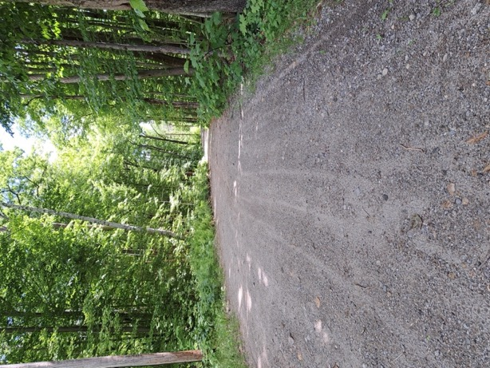
Fortune Road 2025

Jackson Road
Monitor(s): George Beaton

Date of Most Recent Monitoring: May 2026
Mileage: From its junction with Forest Road, Jackson extends approximately 0.3 miles to Howlett Road. The road is reasonably flat.
Erosion: Yes, in multiple places, notably around the driveway to 243. Overall, the road is generally in GOOD condition with the exception of several mud holes. 2026 Update: Jackson remains in good shape and can be easily driven over with a car. Local residents are maintaining it.

Obstructions: None noted
Trash/Dumping: None noted.
Recreational Vehicle Trail Signage: None noted

Motorized/Non-motorized Activities: Appears to have a modest amount of residential and recreational traffic.

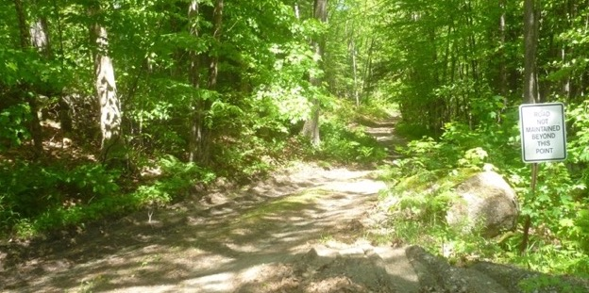
Jackson Road 2022

Liberty Hill Road

Monitor(s): Doug Southard

Date of Most Recent Monitoring: May 2026
Starting at Bradford/Henniker Town Line
Miles
0.00 Road in FAIR condition with frequent pools of water and rocks 4-8 inches high.
0.14 Crushed rock appears to have been placed secondary to a logging operation. Road is FAIR to GOOD from this point forward although significant mud holes appear during rainy weather.
0.2 Previous off-road damage to embankment on West side of a bridge over a small stream appears to be filling in and regrowing.
0.5 LHR ends at 4-way junction with Day Pond Road (both ways) and a private road.
Erosion: Section closest to Henniker has significant erosion. Multiple large mud puddles encountered with vehicle tracks extending the road on both sides. Crushed rock placed on Bradford end makes a more stable surface for the road. However, even here initial signs of a washout are visible. Off-road damage next to bridge appears to be healing with no sign of recent ATV mudding.
Obstructions: No significant obstructions.
Trash/Dumping: No significant dumping noted.
Recreational Vehicle Trail Signage: End of OHRV/ATV trail signs installed in 2025 are present at the Bradford/Henniker town line facing South to Henniker. A single green ATV trail marker was observed on a tree in Bradford heading South toward Henniker just prior to the town line. No other green ATV trail markers were noted along Liberty Road in Bradford. A “No ATV” sign was noted headed South on Liberty Road at the intersection with Day Pond Road.
Motorized/Non-motorized Activities: No ATV activity observed at this time, however, truck tracks were numerous.
Monitor Actions: No actions at this time. Will continue to monitor for any re-establishment of an ATV trail along this road in Bradford.

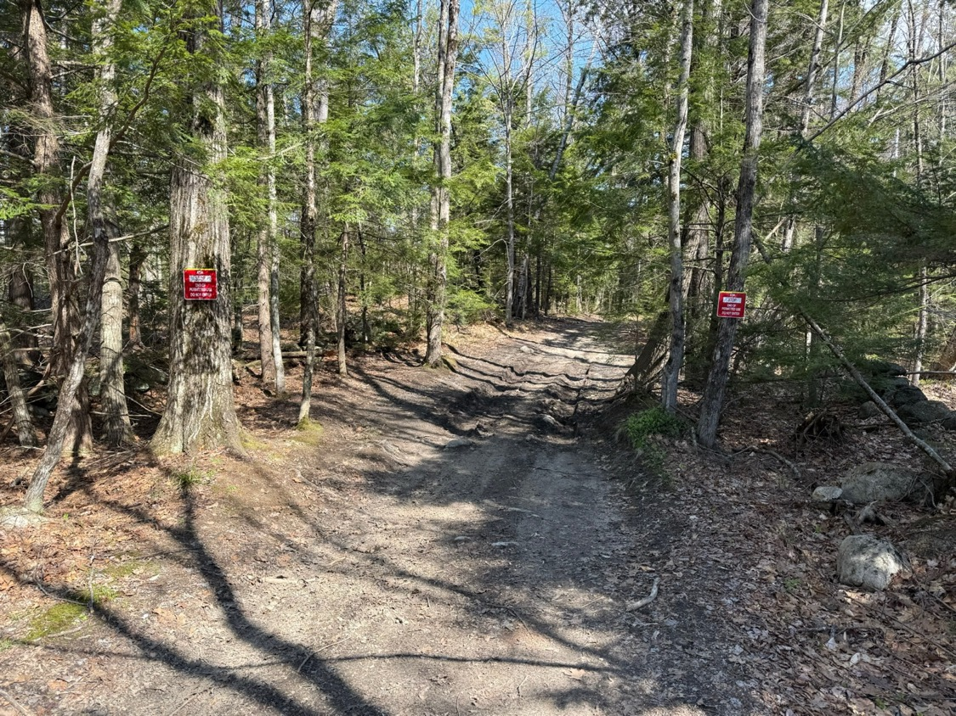
End of ATV Trail Signs Facing Bradford 2026

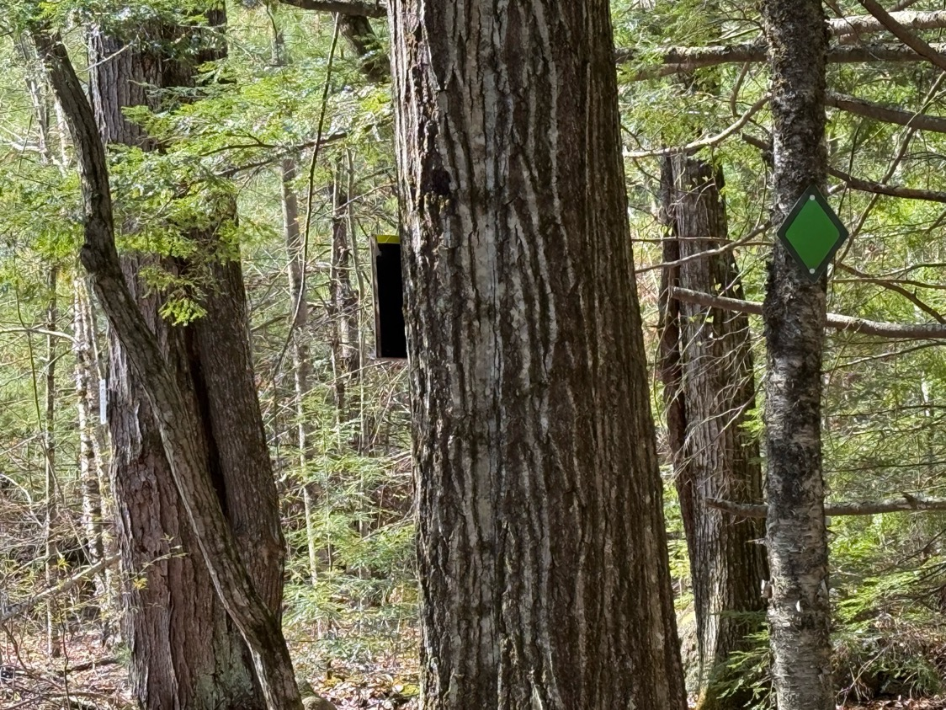
ATV Trail Marker 2026 Facing Henniker

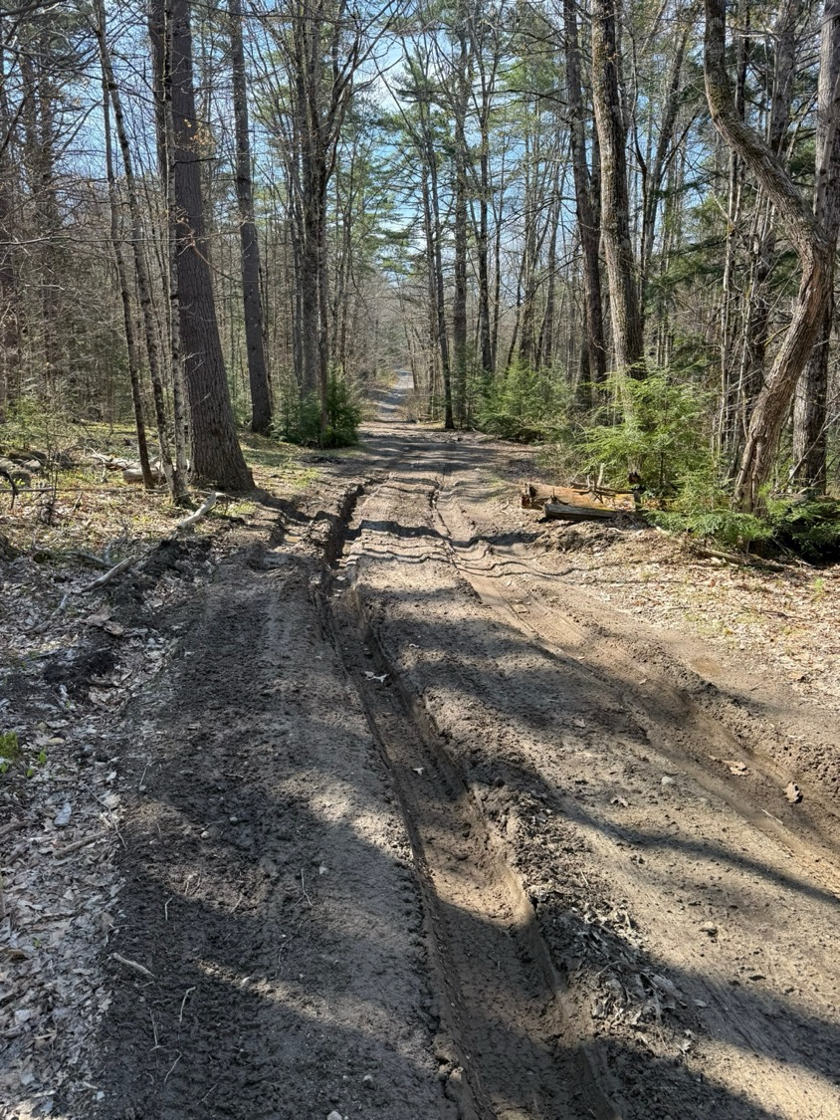
Liberty Road 2026

Massasecum Ave

Monitor(s): Bindy and Doug Southard

Date of Most Recent Monitoring: July 2026
Mileage noted from junction with Rowe Mountain Road, Carter Hill Road, and Day Pond Road.

0.6 Road in generally GOOD condition with isolated rocks and water bars. However, several water bars are quite deep and might be problematic for some vehicles.

Erosion: Washboard surface in places and very deep water bars. However, these improvements seem to have limited overall erosion.

Obstructions: None

Trash/Dumping: Occasional and isolated.

Recreational Vehicle Trail Signage: Snowmobile trail signs noted at junction with Rowe Mtn, Day Pond and Carter Hill Roads. Regular transit of Jeep/truck caravans reported.

Motorized/Non-motorized Activities: Regularly used for motorized access by both residents and recreational. Logging on Massasecum Ave at junction with Day Pond, Carter Hill and Rowe Mountain Roads seems to have concluded.

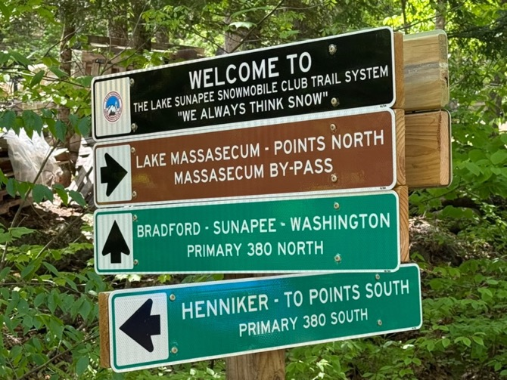
New Snowmobile Club Signs 2025

Old Mountain Road

Monitor(s): Barb and Doug Southard
Date of Most Recent Monitoring: July 2026
Starting at West Rd:
Mile 0.0 to 0.4 - The road is maintained by abutting homeowners. The road surface is currently in GOOD to EXCELLENT condition to 75 OMR. There have been problems in the past with road maintenance disturbing the bank of the adjacent stream (Hoyt Brook), and with road material washing into the brook. Monitor update from June 2025 finds that the stream buffer in the first 0.4 miles continues to look good. Most of new trees in cages planted in 2022 are surviving although a couple were dead or gone.

Mile 0.4 to 0.6 – Road is generally GOOD with deep water bars. The monitors noted a timber laydown area and signs of timber harvesting along the road just past 0.4 miles. A Timber Tax Notice with expiration date 3/31/2025 had been posted by William and Kim Lucas (41 OMR). Just past the lay down area the road had been repaired and stone added to the natural drainage to Hoyt Brook. Haybales observed last year were not intact. The road is posted just past 75 OMR for seasonal use. The road begins to climb and the stream passes through a 3’culvert past 75 OMR. The road over the culvert had been repaired, as last year it had washed out there. As the road climbs a steep hill, it has washed out and subsequently rebuilt by abutters at least four times in the last thirty years, to provide access for forest management.

Mile 0.6 to 0.97 - This section is relatively flat and has been maintained by abutters to the driveway to the Butler camp. It is in FAIR to GOOD condition, with some wet sections where water ponds, and with fords across seasonal streams. The monitors noted a timber laydown area and signs of timber harvesting along the road.
Mile 0.9 to 1.25 - From the Butler driveway to the Washington town line, the road is now in generally GOOD condition with very deep water bars due to recent road work. Town line was easily located.
.
Monitor Actions: None

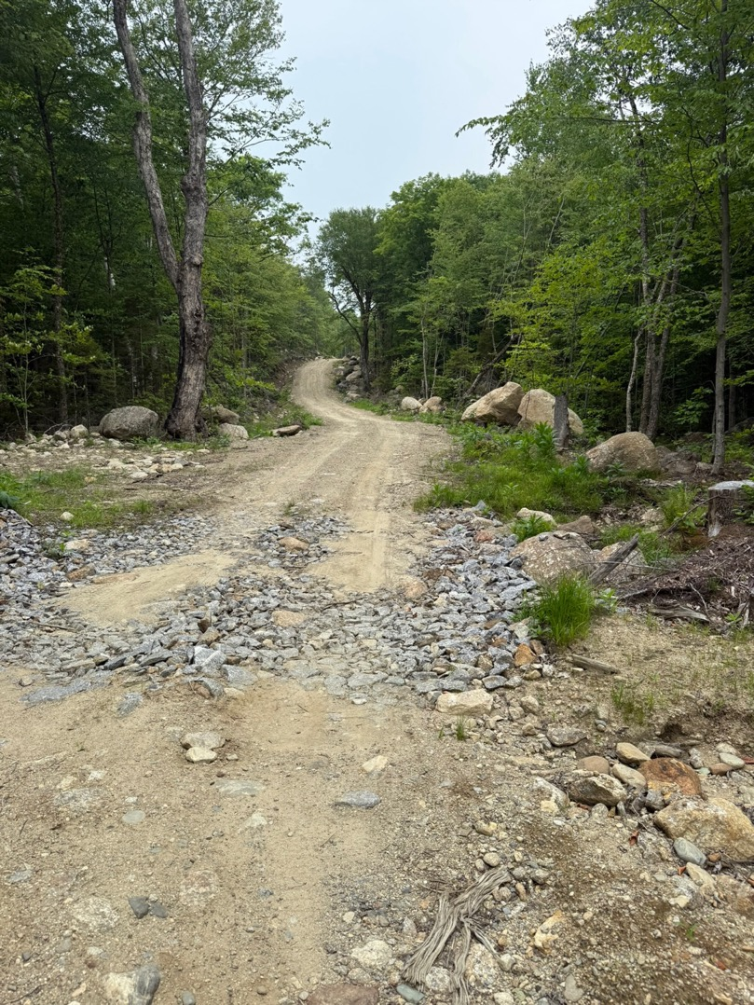
Rebuilt Road Section 2026

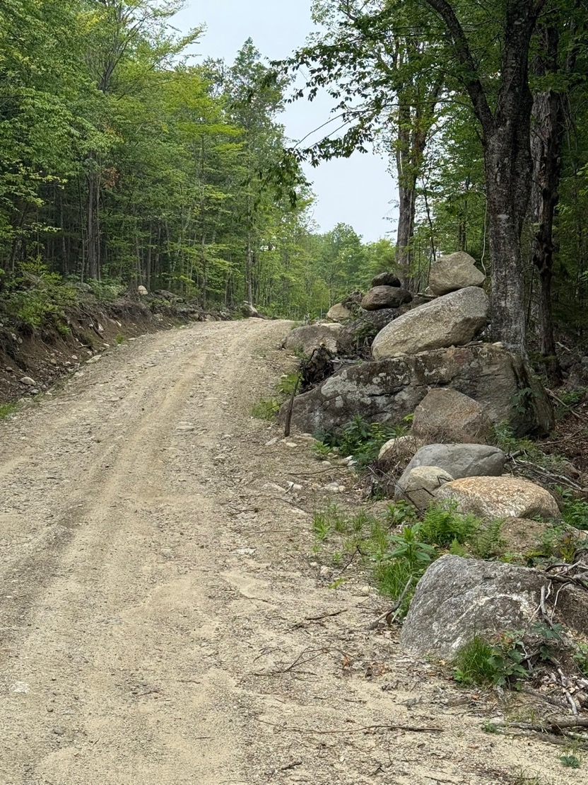
Rebuilt Road Section 2026

Purrington Road

Monitor(s): Barbara and Doug Southard

Date of Most Recent Monitoring: July 2026

Starting at County Road:
Miles
0.16 Road primarily level and in GOOD to EXCELLENT condition. Appears to be privately maintained. At 0.16 miles there is signage indicating transition to private property. A new STOP sign appears to be recent as of 2024.
Erosion: Generally not significant.

Obstructions: None.
Trash/Dumping: No dumping observed.

Recreational Vehicle Trail Signage and Motorized Activities: The road sign posted for Mud Season Closure at the juncture with County Road has been damaged/disassembled and laying by the side of the road.
Monitor Actions: Road Agent to be notified regarding the damaged Mud Season sign.

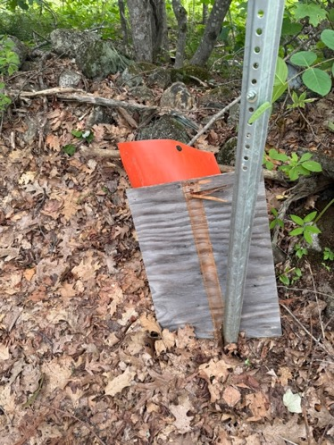
Damaged Mud Closure sign 2026

Rowe Mountain Road

Monitor(s): Doug Southard

Date of Most Recent Monitoring: June 2026

Starting at the beginning of the Class VI section of RMR from the Class V Section
Miles
0.0 Road initially level and then climbs up a significant hill. At 150 feet there is a new culvert installed in 2022 by the Sunapee Snowmobile Club. Snowmobile trail off Southard property enters at about 0.15 miles. Overall road condition in the first 0.1 miles is initially GOOD due to crushed rock being laid associated with a timbering operation. Unfortunately, significant washout remains from the July 2021 rainstorm just after the 0.15 mile point. From 0.2 miles to 0.75 miles the road appears only FAIR as the crushed rock is minimal compared to the first section and there are frequent rock outcrops.
0.65 Snowmobile trail detour to the left (Northside).
0.75 Road conditions deteriorate substantially. Gentle downslope with significant rock outcropping, ledge and general erosion. Road condition is POOR.
0.94 1st camp noted on right (Southside). Some crushed rock on road and conditions improve to GOOD.
1.0 End of snowmobile trail detour which comes in from the left. Road improves to EXCELLENT.
1.7 RMR ends at four corners with Massasecum Road, Day Pond Road, and Carter Hill Road. Junction is FAIR to GOOD depending upon time of year and weather conditions. Can become a mud hole.
Erosion: Entire road suffers from erosion, however, the section from 0.75 to 0.94 miles is extremely eroded. Rocks/ledge drops of 1-2 feet are frequent in this section. Significant erosion in first 0.25 mile is new since July 2021.

Obstructions: Other than the ledge noted above, no significant obstructions at this time.

Trash/Dumping: No significant dumping noted.

Recreational Vehicle Trail Signage: Snowmobile signage noted off Southard property and at 0.65 mile point as noted above. Gate in place at Southard property. New signage noted in 2025 at end of Rowe Mountain Road at junction with Massasecum, Day Pond and Carter Hill Roads.

Motorized/Non-motorized Activities: Jeep/truck caravans and dirt bikes are frequent on weekends. ATV usage seems to have decreased a bit over the past year. Bradford police have been responsive to citizen complaints regarding ATVs on this road.
Other: Sign at beginning of Class VI section indicating road closure for mud season is labeled as April1 – May 31.

Monitor Actions: Mud closure sign dates refreshed.

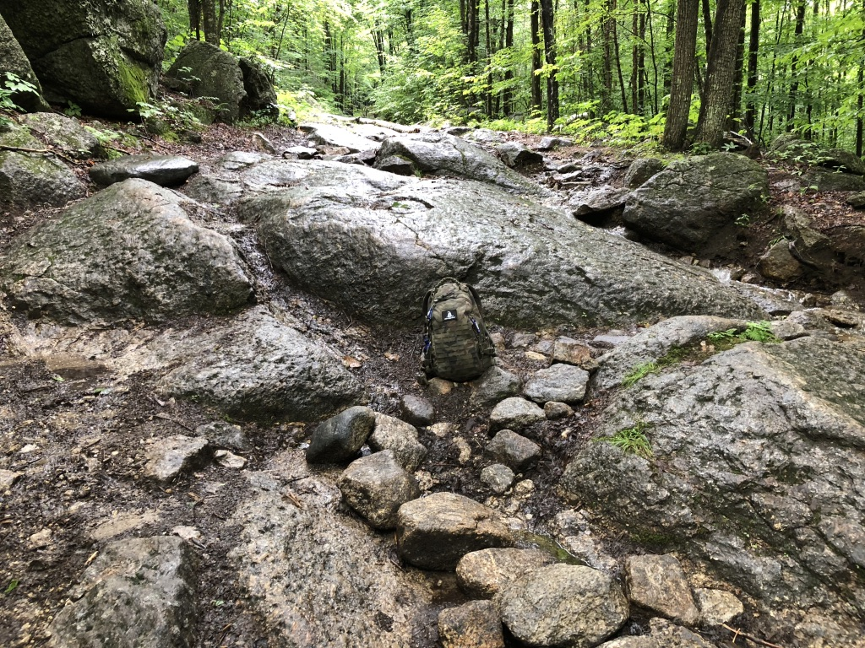
Erosion on Rowe Mtn Road 2018-26

Smith Road

Monitor(s): George Beaton and Doug Southard

Date of Most Recent Monitoring: May & July 2026

Road Conditions: Starting at the Junction of Smith Road and Rowe Mountain Road

Miles
0.38 Intersection with Tuttle Road – FAIR to GOOD
0.48 Hill – GOOD to EXCELLENT
0.70 Smith Cellar Hole – EXCELLENT
0.72 Old logging landing – EXCELLENT
1.22 Ends on Forest Ave – EXCELLENT
Erosion: Conditions from Forest St to Tuttle Rd are generally EXCELLENT. The improvements made in 2024 by the landowner on Tuttle Rd have held up quite well. From Tuttle Rd to Rowe Mt Rd some sections have been filled with crushed rock and are in good shape.

Obstructions: Occasional small tree down, nothing significant observed.

Trash/Dumping: Nothing significant.

Recreational Vehicle Trail Signage: Snowmobile trail signs evident at cutoff for trail through Southard property toward the intersection with Rowe Mountain Road.

Motorized/Non-motorized Activities: Evidence of dirt bikes and other vehicles. No significant ruts/erosions from these tracks noted. Road posted for mud season closure at both ends, however, sign on the Forest St. side needs repair.

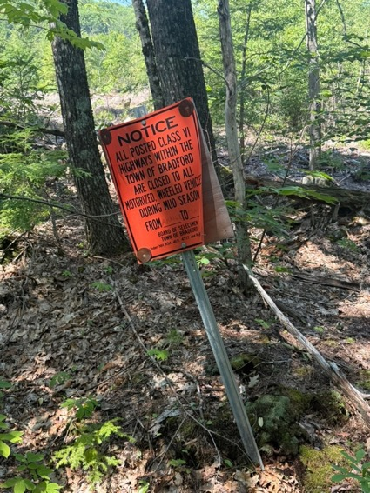
Sign Needing Repair 2026
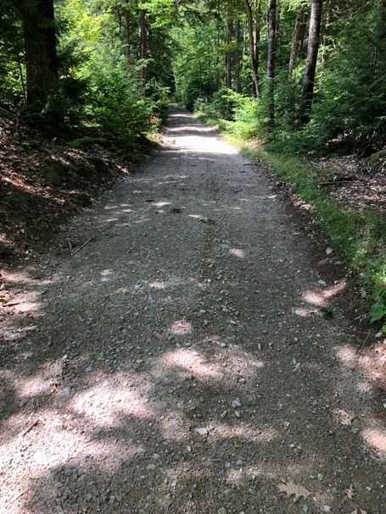
Privately Upgraded Road Surface July 2024

